### HOTEL RESERVATION REQUEST



**Seoul Hongdae**

♦ Please complete this form and return directly by e-mail or FAX to us.

Reservation. Tel: +82 768 3000, Fax: +82 768 3001, E-mail: reservation@hiex-seoulhongdae.com

|  |  |
| --- | --- |
| Last Name (Mr./Ms.): | First Name: |
| Event : KOPLAS 2021 | |
| Organizer: KOREA E&EX INC | |
| Phone No.: | Email: |
| Room Type: | Sharing Room with: |
| Check-in Date: | Arrival Flight No./ Time: |
| Check-out Date: | Departure Flight No./ Time: |

♦ Offer Rate: *VAT Inclusive

|  |  |  |  |  |
| --- | --- | --- | --- | --- |
| Hotel | Room Type | Size | Room Rate | Breakfast |
| **Holiday Inn**  **Express**  **Seoul**  **Hongdae** | **Superior**  **Double**  (Queen) | **22sqm** | **□ KRW77,000**  (*USD 70~) | **□ Complimentary**  **(2PAX)** |
| **Superior**  **Twin**  (Single x 2) | **22sqm** | **□ KRW88,000**  (*USD 80~) | **□ Complimentary**  **(2PAX)** |

* All government tax and service charge are included on the offered rate.

* Cancellation or No Show on the arrival date will be charged as a full night’s rate per room.

* Parking Fee is KRW 10,000 /Night at the YZ Park parking lot.

* Airport Limousine 6002, A’REX Airport Subway ICN(50min), GMP(20min)

* M Bus 7731 is the best public transportation from Hongdae to KINTEX

♦ A credit card number is required to guarantee your reservation.

|  |  |
| --- | --- |
| Card: □ Amex □ Diners □ Master □ Visa □ JCB | 4 digit # for AMEX: _ _ _ _ |
| Card Number: | Expiry Date: |

* Check-in time - 3:00 pm, Check-out time - 12:00 noon.

♦ Please indicate special requests and comments;

Date: Signature:

**Hongik Univ. Station ↔ KINTEX M Bus information.**

홍대입구역 ↔ 킨텍스 광역급행버스 안내

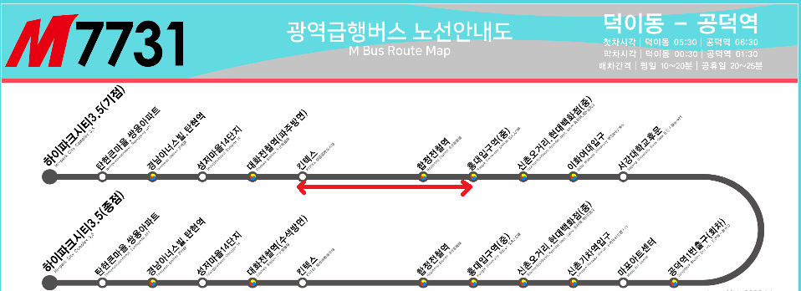

**Bus Stop**

( Hongdae → Swiss Grand Hotel Convention Center)

Gate No.3 Hongik Univ. Station

